Feature Cards / CTA Module
501 Website Landing Page — Observe the three coloured cards in the section below the header of the 501 website. These three cards currently exist as images, and must be manually edited by a designer and replaced when figures need changing.
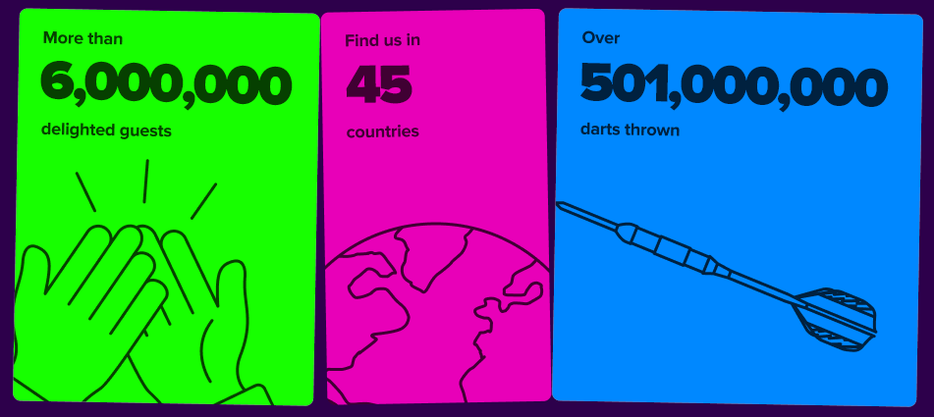
An example of the feature cards module.

Your Task:
Create a reusable, accessible module or component for a marketing landing page. It should be well-documented, well-structured, accessible, responsive and CMS-agnostic, with potential to integrate with any given CMS with minimal adjustment.
You are encouraged to use vanilla HTML, CSS and JS with native browser APIs. Justify your methodology and approach in code-comments or in an external text file.
A link to the code on GitHub and a working example will be required.

Please also provide portfolio links for websites that you have worked on.

